AdMax -2952

On page : SEM → Account → Search Engine Setup

- Choose a campaign to be assigned in the grid “New Search Engine Accounts”
- Select the account you want to assign to the drop “TSA Account” and check “Sync Enabled” or do it through the editor.

- In the example, seeks to assign the Campaign #12

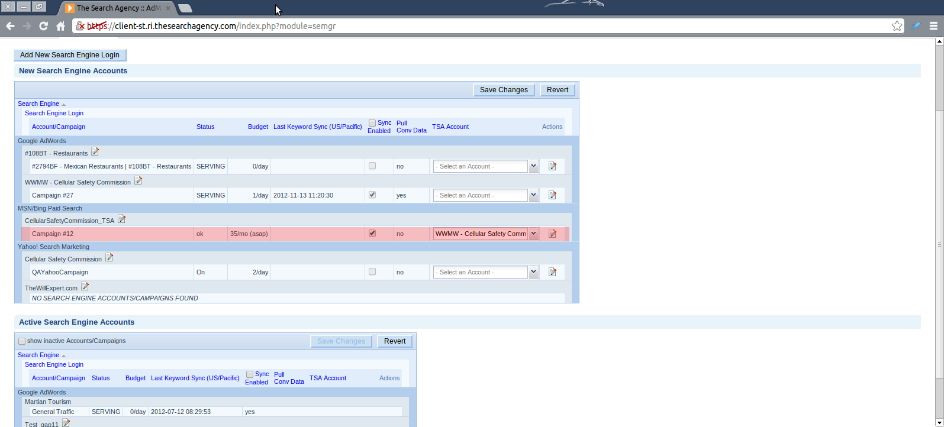

- Click on the button “Save Changes” or the button “OK” in the editor
- Changes look in the grid “Active Search Engine Account”



